

A Project Report

On

“**FarmConnect: Empowering Farmers with a Unified Ecosystem”**

Batch Details

|  |  |
| --- | --- |
| **Roll Number** | **Student Name** |
| 20211CAI0079 | LAVANYA RAMACHANDRA |
| 20211CAI0148 | KAMINI PRAJAPATHI S |
| 20211CAI0165 | MEKALA SAI LAKSHMI |
| 20211CAI0145 | TEJASWINI K A |

**School of Computer Science & Engineering**

**Presidency University, Bengaluru**

Under the guidance of,

**Dr. Akshatha Y​,**

**Assistant Professor - Senior Scale​**

Presidency School of Computer Science,

Presidency University, Bengaluru

**CONTENTS**

1. Introduction about Project

1. Literature Review

1. Objectives

1. Methodology

1. Timeline for Execution of Project

1. Expected Outcomes

1. Conclusion

1. References

**1.Introduction about project:**

Farmers play a crucial role in ensuring food security and supporting local economies, yet they often face significant challenges that impede their productivity and profitability. Accessing essential resources—such as leasing equipment, securing agricultural credit, and selling produce at local markets—can be particularly daunting. Many farmers struggle with high costs and limited access to modern agricultural practices, which can lead to inefficiencies and diminished returns.

Compounding these issues are information gaps that leave farmers without the knowledge necessary to make informed decisions about crop management, pest control, and market timing. As a result, many farmers find themselves operating in isolation, unable to connect with the vendors and resources that could enhance their operations.

FarmConnect addresses these critical challenges by offering a comprehensive platform designed to streamline farming operations. By providing features such as order tracking, vendor connections, access to expert advice from local agricultural universities, and market location services, FarmConnect empowers farmers throughout the agricultural cycle. This innovative solution not only enhances efficiency but also fosters a sense of community among farmers, enabling them to share resources and knowledge. Ultimately, FarmConnect represents a vital step toward improving agricultural practices, increasing productivity, and ensuring sustainable farming for the future.

**2.Literature Review:**

FarmConnect, designed as an open ecosystem platform, builds on the growing body of literature that emphasizes the role of technology in driving sustainable agricultural practices and farmer empowerment. Key research highlights the significant impact of digital platforms and mobile applications in transforming the agricultural landscape, particularly for smallholder farmers.

Digital platforms, similar to FarmConnect, have proven successful in digitizing farmer profiles to assess creditworthiness and offer tailored financial products. These platforms also provide farmers with access to local vendors, expert advice, and market opportunities, supporting sustainable farming by improving visibility across the agri-ecosystem and enabling financial inclusion.

**Ecological Intensification and Technological Integration**

Ecological Intensification (EI) emphasizes the use of ecological processes and natural resources to improve agricultural productivity in a sustainable manner. According to various studies, EI is essential for enhancing resilience in farming, particularly in the face of climate change and environmental degradation. However, implementing EI practices at scale has been a challenge due to farmers’ limited access to the necessary resources, tools, and knowledge. Technological integration—such as that envisioned by FarmConnect—provides an effective solution by making ecological innovations more observable and trialable. Platforms that offer real-time advice, link farmers to local vendors for agri-inputs, and provide access to expert guidance make it easier for farmers to adopt and experiment with sustainable practices. Through EI and technology, farmers can achieve greater productivity while maintaining long-term environmental sustainability.

**Role of Digital Platforms in Farmer Enablement**

Digital platforms have emerged as critical tools for farmer enablement, enhancing visibility and financial inclusion across the agricultural ecosystem. Studies show that digital tools can profile farmers using Know Your Customer (KYC) processes and socio-economic data, enabling stakeholders to assess creditworthiness and offer tailored financial products, such as microloans and crop insurance. By digitizing this information, platforms like FarmConnect ensure that farmers are not only able to access financial services but also maintain a digital presence that strengthens their credibility in the marketplace. Additionally, these platforms connect farmers to local vendors, universities for expert advice, and market access, thus bridging gaps in knowledge and resources. Through this, farmers can make informed decisions regarding sustainable practices, access the latest farming techniques, and receive updates on relevant government initiatives and policies.

**Impact of Mobile Applications on Agriculture**

Mobile applications have revolutionized the agricultural sector, particularly for smallholder farmers, by providing critical information at their fingertips. Numerous studies highlight how mobile apps deliver real-time updates on weather conditions, crop prices, and pest control, which are crucial for informed decision-making. For example, weather updates enable farmers to better plan their planting and irrigation schedules, thus reducing risks related to unpredictable climate patterns. Moreover, mobile apps also serve as a direct link between farmers and buyers, eliminating the need for intermediaries and ensuring fair pricing. This direct connection with markets enhances farmers’ financial stability, which in turn empowers them to invest in better-quality inputs and adopt sustainable farming practices. Apps like "Apni Kheti" and "Krishi Network" provide farmers with information on field preparation, sowing, fertilizers, crop protection, and harvesting, as well as livestock management and government schemes, contributing to higher productivity and reduced costs.

**FarmConnect’s Vision for a Connected Ecosystem**

FarmConnect’s vision to provide a one-stop platform for farmers aligns with the growing emphasis on open ecosystem platforms. By digitizing the farming cycle and offering end-to-end services—from retailing and leasing to connecting farmers with local vendors and experts—FarmConnect addresses the fragmented nature of current agricultural systems. The literature shows that integrated platforms improve transparency across the agri-ecosystem, allowing for real-time data sharing, which benefits all stakeholders, including development agencies, agri-companies, and financial institutions. For example, platforms that incorporate financial services such as crop insurance and agri-credit have proven instrumental in empowering farmers with the capital necessary for improving yields and adopting sustainable practices.

Furthermore, FarmConnect’s potential to connect with universities and agri-experts for expert advice mirrors the growing trend of using technology to foster knowledge transfer. Studies show that the lack of access to timely and accurate information is one of the key barriers to the adoption of sustainable agriculture. Digital platforms overcome this by ensuring that farmers receive tailored advice and updates, making them more resilient to market and environmental fluctuations.

The integration of digital platforms and mobile applications in agriculture has shown a transformative impact on smallholder farmers, particularly in terms of access to information, financial services, and market linkages. By leveraging these tools, platforms like FarmConnect can address the core challenges facing farmers today, including limited visibility, access to financial products, and the adoption of sustainable practices. The literature suggests that combining ecological intensification with technological solutions is critical for achieving long-term sustainability in agriculture. FarmConnect’s model of providing an open ecosystem for farmers, where they can access a wide range of resources and services, is well-aligned with the broader trends in agricultural innovation, driving productivity, and enhancing sustainability.

|  |  |  |  |  |  |  |
| --- | --- | --- | --- | --- | --- | --- |
| **S.NO** | **Year** | **Author(s)** | **Title** | **Outcomes** | **Advantages** | **Limitations** |
| 1 | 2020 | Daniel Kpienbaareh, Rachel Bezner Kerr, Isaac Luginaah, Jinfei Wang, Esther Lupafya, Laifolo Dakishoni, Lizzie Shumba | Spatial and Ecological Farmer Knowledge and Decision-Making about Ecosystem Services and Biodiversity | Insights into spatial and ecological knowledge for ecosystem management | Enhances local decision-making | May be region-specific, challenging to scale |
| 2 | 2020 | Manish Kumar, Lalit Agrawal | Empowering Farming Community Through Mobile Applications: Changing Scenarios | Positive impact of mobile apps on farmer connectivity | Increased access to information and market | Digital literacy and infrastructure challenges |
| 3 | 2021 | Maria Kernecker, Verena Seufert, Mollie Chapman | Farmer-centered Ecological Intensification | Advocates for ecological intensification centered on farmers | Enhances sustainability through local practices | Scaling up practices can be complex |
| 4 | 2022 | Kumar, Mr & Sahithi, Ms & Sheerin, Ms & Aakanksha, Ms & Reddy, Mr | Uplifting the Farmer Through Connected Ecosystems | Emphasizes importance of ecosystem connectivity | Improves farmer access to resources | Requires investment in technology |
| 5 | 2022 | Mr Abhishek Beriya | India Digital Ecosystem of Agriculture and Agristack: An Initial Assessment | Analysis of India's digital agriculture initiatives | Potential for data-driven decisions | Privacy and data security concerns |
| 6 | 2022 | Muthumanickam Dhanaraju, Poongodi Chenniappan, Kumaraperumal Ramalingam, Sellaperumal Pazhanivelan, Ragunath Kaliaperumal | Smart Farming: Internet of Things (IoT)-Based Sustainable Agriculture | IoT-based solutions for farming | Precision farming and resource optimization | High initial costs and technical expertise required |
| 7 | 2023 | Kamal, Mostafa & Bablu, Tarek | Mobile Applications Empowering Smallholder Farmers: An Analysis of the Impact on Agricultural Development | Impact of mobile apps on smallholder farmers | Improved access to markets and resources | Limited reach in rural areas |
| 8 | 2023 | Mostafa Kamal, Tarek Aziz Bablu | Mobile Applications Empowering Smallholder Farmers: An Analysis of the Impact on Agricultural Development | Focuses on mobile apps for smallholder farmers | Streamlines communication and market access | Adoption challenges among older farmers |
| 9 | 2023 | Jayanth Murthy | How to Enable a Supportive Ecosystem for Agriculture Supply Chains in India | Focuses on strengthening supply chains | Improved efficiency in supply chains | Needs policy support for implementation |
| 10 | 2024 | Sujit Janardanan | How to Empower and Engage Your Farmers to Promote Sustainable Practices | Strategies for promoting sustainability among farmers | Better adoption of sustainable practices | Requires continuous engagement and support |

**3.Objectives:**

* **Enhance Access**: Provide farmers with easy access to leasing options for farm machinery and secure agri-credit.​
* **Streamline Operations**: Integrate multiple services into a single platform, reducing complexity in managing farming activities.​
* **Facilitate Market Connectivity**: Help farmers easily locate nearby mandis and gain real-time information on market prices.​
* **Improve Financial Management**: Enable farmers to track transaction history, manage personal and farming expenses efficiently.​
* **Boost Productivity**: Empower farmers to make informed decisions, ultimately increasing their productivity and profitability.​
* **Ensure User Accessibility**: Offer multilingual support to cater to a diverse farming community, ensuring inclusivity.​

## Experimental Details:

* **Figma:** Used to design the UI/UX of the app with interactive prototypes.​
* **XML (Frontend)**: Used to design the user interface (UI) layout in Android apps.​
* **Java (Backend):** Implements the business logic and connects the frontend to the database.​
* **Firebase (Database)**: A cloud-based NoSQL database providing real-time data syncing and storage.​
* **Android Studio (Toolkit)**: The official IDE for Android development, offering tools to build, test, and debug apps.​
* **Android SDK**: A set of development tools and libraries used to build Android applications.​

Architecture: 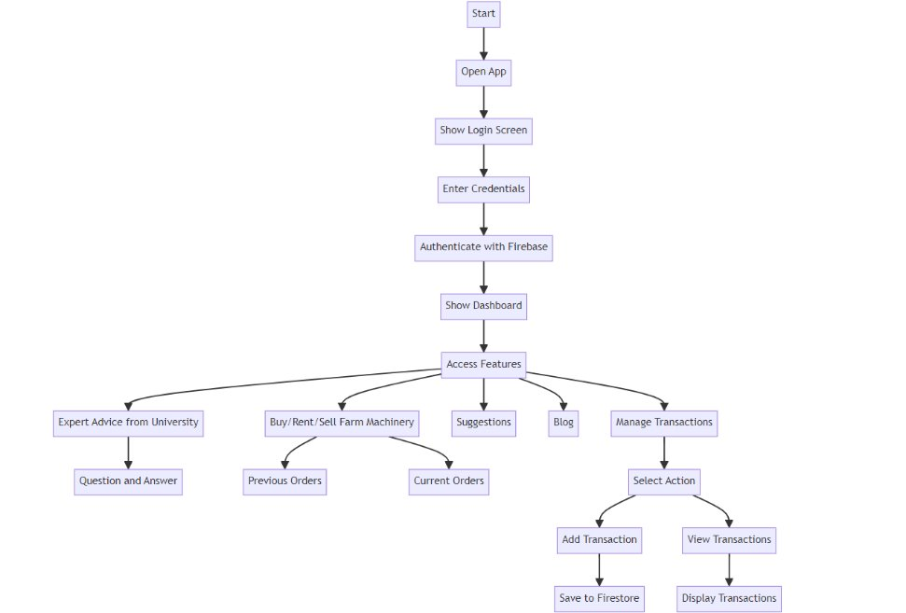

**4.Methodology**:

* **Research and Analysis**: Conduct surveys and analyze with the farmers to identify their needs and challenges.​
* **Design**: Develop the app's user interface and experience, focusing on simplicity and usability.​
* **Development**: Utilize Java for backend and XML for frontend, integrating Firebase for data storage.​
* **Testing**: Implement comprehensive testing to ensure functionality and usability, addressing any issues identified.​
* **Deployment**: Launch the app on relevant platforms and provide training for users.​
* **Support and Improvement**: Continuously gather user feedback for updates and enhancements to ensure the app meets evolving needs.​

**Design Procedure:**

* **Requirement Gathering**: Understand the needs of farmers, including features like leasing, agri-credit, market access, and expert advice. Collect feedback through surveys and interviews.
* **Wireframing**: Use **Figma** to create low-fidelity wireframes that outline the app's layout and flow, focusing on simplicity and usability for farmers.
* **UI/UX Design**: Develop high-fidelity designs in Figma, focusing on an intuitive interface with easy navigation. Ensure the design accommodates multilingual support and accessibility.
* **Prototyping**: Create interactive prototypes in Figma to simulate user interactions and refine the design based on user feedback.
* **Frontend Development**: Use **XML** to translate the designs into a functional user interface, ensuring responsive layouts for mobile devices.
* **Backend Integration**: Develop the backend logic using **Java**, connecting the frontend to **Firebase** for real-time data storage and syncing.
* **Testing**: Conduct usability testing with target users (farmers) to ensure the design is functional and intuitive, making adjustments as needed.
* **Iteration**: Continuously improve the design based on feedback from testing and real-world usage.

**5.Expected Outcomes:**

1. **Increased Efficiency:**

- Streamlined access to machinery leasing, reducing downtime and enhancing productivity.

2. **Improved Access to Financing:**

- Enhanced availability of agricultural credit, allowing farmers to invest in inputs and technology.

3. **Informed Selling Decisions:**

- Access to real-time market insights enabling better timing and pricing strategies for selling produce.

4. **Enhanced Financial Oversight:**

- Transaction tracking tools providing clarity on income and expenses, promoting better financial management.

5. **Timely Expert Guidance:**

- Direct access to agricultural experts for advice on crop management and business planning.

6. **Greater Accessibility:**

- Multilingual support ensuring the platform is user-friendly for a diverse farmer population.

7. **Increased Profitability:**

- Improved decision-making and resource acquisition leading to higher overall farm profitability.

8. **Promotion of Sustainable Practices:**

- Empowerment of farmers to adopt sustainable agricultural methods through enhanced knowledge and resources.

9. **Stronger Community Connections:**

- Potential for networking and collaboration among farmers through a shared platform.

10. **Resilience in Agriculture:**

- Greater ability for farmers to adapt to market changes and challenges, contributing to the sustainability of the agricultural sector.

**6.Time Line of the project/Project Execution plan:**

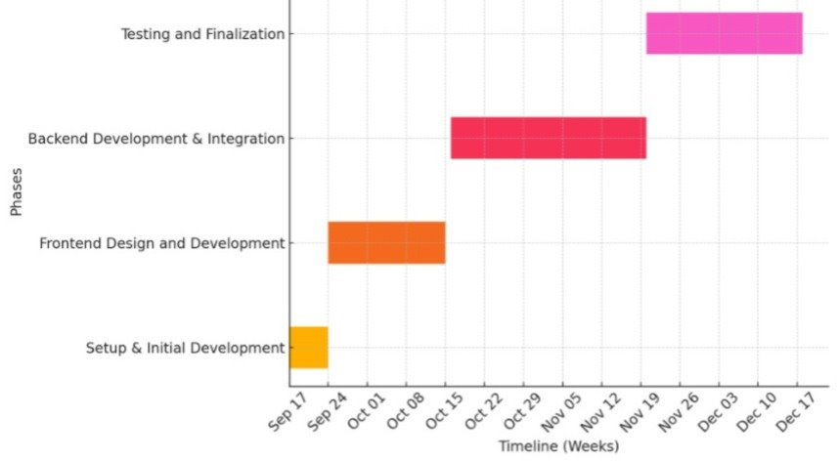

**7.Conclusion:**

In conclusion, FarmConnect stands as a pivotal solution to the myriad challenges faced by farmers today, addressing issues of access, efficiency, and sustainability through its integrated platform. By consolidating essential services—such as machinery leasing, financial resources, market insights, and expert guidance—into one user-friendly interface, FarmConnect significantly reduces the barriers that farmers encounter in their day-to-day operations. This comprehensive approach not only enhances access to critical resources but also fosters direct connections to markets, enabling farmers to maximize their income potential while minimizing reliance on intermediaries.

Moreover, the platform’s commitment to inclusivity ensures that farmers from diverse backgrounds can benefit from its offerings, promoting equity within the agricultural sector. By providing tools for better financial management and decision-making, FarmConnect empowers farmers to optimize their operations, leading to increased productivity and profitability. This empowerment is crucial in a rapidly changing agricultural landscape where adaptability and informed choices can make a substantial difference.

FarmConnect's vision extends beyond immediate economic benefits; it seeks to foster sustainable agricultural practices that contribute to environmental health and resilience. By equipping farmers with the knowledge and resources needed to implement sustainable methods, the platform not only enhances individual farm viability but also contributes to the overall sustainability of the agricultural ecosystem. As FarmConnect facilitates the transition towards more sustainable farming practices, it plays a vital role in securing a brighter future for farmers and the communities they support. In essence, FarmConnect is not just a tool for today; it is an investment in the future of agriculture, promising to enhance livelihoods while nurturing the planet.

**8.References:**

[1] Kamal, Mostafa & Bablu, Tarek. (2023). Mobile Applications Empowering Smallholder Farmers: An Analysis of the Impact on Agricultural Development. 8. 36-52. ​

[2] Kumar, Mr & Sahithi, Ms & Sheerin, Ms & Aakanksha, Ms & Reddy, Mr. (2022). UPLIFTING THE FARMER THROUGH CONNECTED ECOSYSTEMS. YMER Digital. 21. 537-542. 10.37896/YMER21.04/54 ​

[3] Mr Abhishek Beriya.(2022).India Digital Ecosystem of Agriculture and Agristack: An Initial Assessment ICT India ​

[4] Maria Kernecker, Verena Seufert, Mollie Chapman. April(2021). Farmer-centered ecological intensification. ​

[5] Sujit Janardanan.July(2024)How to Empower and Engage your Farmers to Promote Sustainable Practices. ​

[6] Daniel Kpienbaareh ,Rachel Bezner Kerr, Isaac Luginaah, Jinfei Wang, Esther Lupafya, Laifolo Dakishoni,Lizzie Shumba. Sep(2020). Spatial and Ecological Farmer Knowledge and Decision-Making about Ecosystem Services and Biodiversity. ​

[7] Muthumanickam Dhanaraju ,Poongodi Chenniappan, Kumaraperumal Ramalingam, Sellaperumal Pazhanivelan,​Ragunath Kaliaperumal. Oct(2022).Smart Farming: Internet of Things (IoT)-Based Sustainable Agriculture. ​

[8] Manish Kumar, Lalit Agrawal. Mar(2020). Empowering Farming Community Through Mobile Applications: Changing Scenarios. ​

[9] Jayanth Murthy. Oct(2023). How to enable a supportive ecosystem for agriculture supply chains in India ​

[10] Mostafa Kamal, Tarek Aziz Bablu. Jun(2023). Mobile Applications Empowering Smallholder Farmers:An Analysis of the Impact on Agricultural Development​

**Project work mapping with SDG:**

* No Poverty (1)​
* Zero Hunger (2)​
* Decent Work and Economic Growth (8)​
* Industry, Innovation and Infrastructure (9)​
* Reduced Inequalities (10)​
* Sustainable Cities and Communities (11)​
* Partnerships for the Goals (17)

**GitHub Link:**